Without init container:

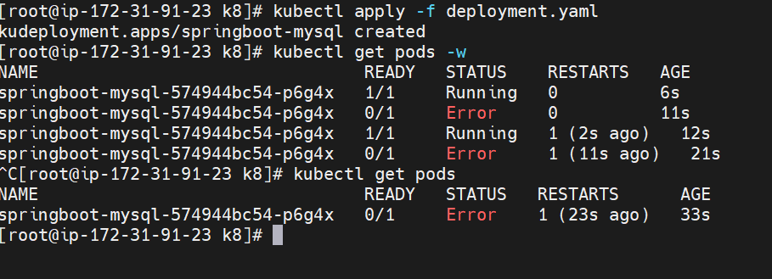

If we check the logs it showing

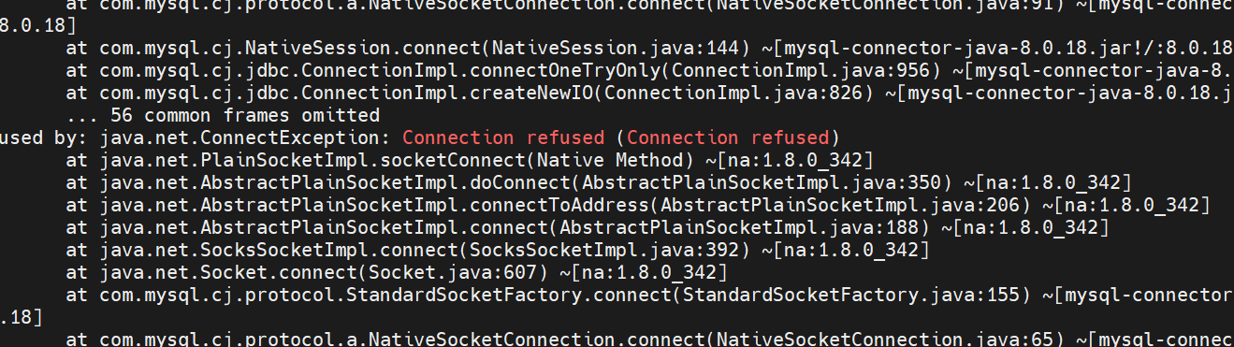

With init container

initContainers:

- name: init-db

image: busybox:1.31

command: ['sh', '-c', 'echo -e "Checking for the availability of MySQL Server deployment"; while ! nc -z mysql-service 3306; do sleep 1; printf "-"; done; echo -e " >> MySQL DB Server has started";']

I was not created any service

Error with liveness and rediness probes

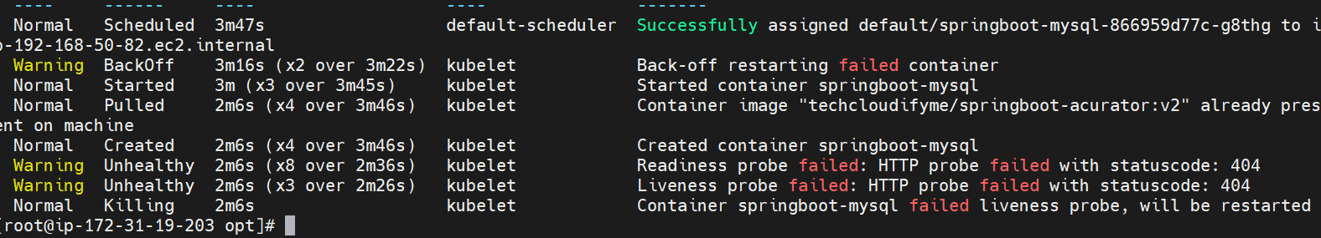

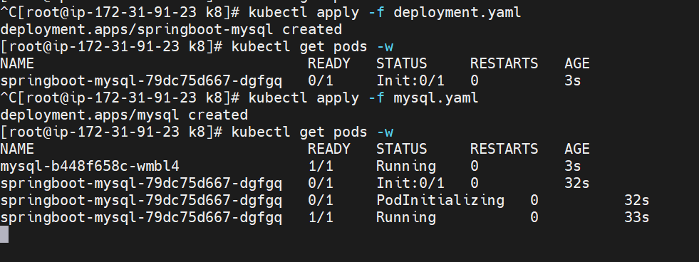

This **initContainers** section is commonly used to delay the start of the main containers until a dependent service or resource (in this case, the MySQL server) is ready.

Make sure to adjust the **mysql** hostname to match the service name or hostname of your MySQL server in the Kubernetes cluster.

The **nc -z** command is used to check if the MySQL server is reachable on port 3306.

Probes:

We are giving initial delay seconds 60 until 60 second status will 0/1 only

I am getting nodes scheduling disabled

To make nodes ready use the following commands

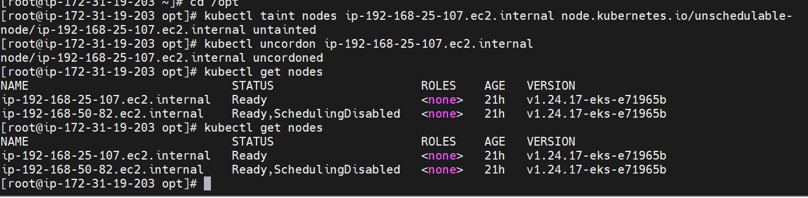

ip-192-168-25-107.ec2.internal Ready,SchedulingDisabled <none> 20h v1.24.17-eks-e71965b how we do scheduling enabled

If the node is marked as "SchedulingDisabled," it means that it is currently set to not receive new pods. To enable scheduling on the node, you can use the following steps:

1. **Remove Unschedulable Taint:** The most common reason for a node to be marked as unschedulable is the presence of a taint. You can remove the taint using the **kubectl taint** command. For example:

bashCopy code

kubectl taint nodes ip-192-168-25-107.ec2.internal node.kubernetes.io/unschedulable-

This command removes the **node.kubernetes.io/unschedulable** taint from the node, allowing it to be scheduled.

1. **Uncordon the Node:** If the node was cordoned, you can use the **kubectl uncordon** command to make it schedulable again:

bashCopy code

kubectl uncordon ip-192-168-25-107.ec2.internal

This command allows the node to start accepting new pods for scheduling.

After performing one of these actions, the node should become schedulable again, and the status should change from "SchedulingDisabled" to "Ready" in the **kubectl get nodes** output.

Before making any changes, ensure that you understand why the node was marked as unschedulable. If it was done intentionally for maintenance or other reasons, make sure your actions align with your cluster management strategy. If it was due to specific issues, resolving those issues might be necessary before enabling scheduling on the node.